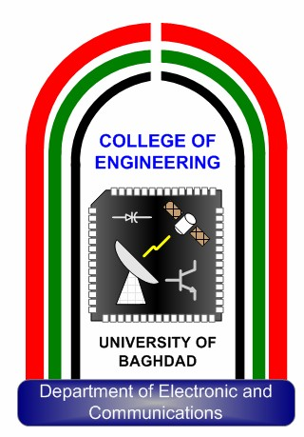
Contactless smart human thermometer for medical applications
A Report
University of Baghdad
College of Engineering
Department of Electronics and
Communication

Submitted to the Department of Electronics and Communication
Engineering / College of Engineering/ University of Baghdad, in
Partial Fulfillment of the Requirements for the
Bachelor Degree in Electronics and Communication Engineering
By
حسن سامال عبدالله عباس
Supervisored by
م. د. سنان صباح محمود

2026 1443

Acknowledgement

G

Abstract

h

Table of contents

Chapter One

Introduction and Theoretical
Background

